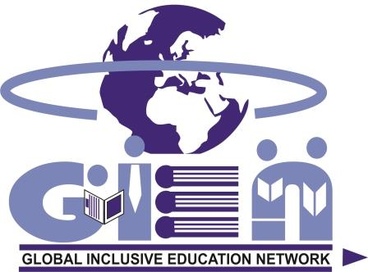

Presents
NATIONAL CONFERENCE ON INCLUSIVE EDUCATION

CALL FOR PAPERS
(SUBMIT FULL PAPER / CASE STUDY-
NO ABSTRACT REQUIRED)
BY
30 JUNE 2020
NOTIFICATION DATE 31 JULY 2020

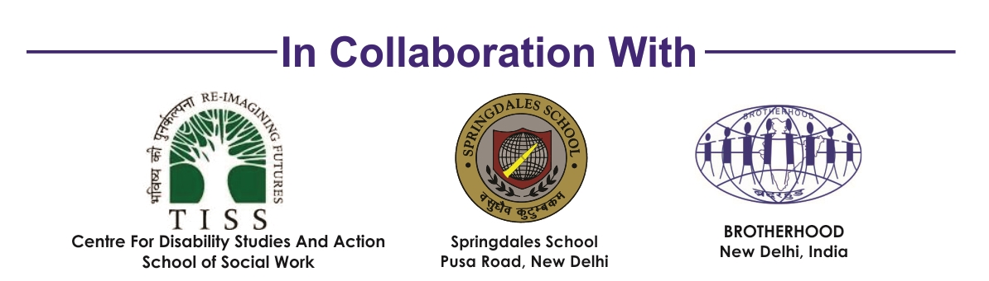
30 March 2020

Dear friends,

Greetings from GIEN Team!
The Show must go on…

SUBMIT FULL PAPER / CASE STUDY TILL 30 JUNE 2020-NOABSTRACT REQUIRED

As suggested by the Government of India, we are all staying at home to safe ourselves, our family and country from COVID-19.

The GLOBAL INCLUSIVE EDUCATION NETWORK (GIEN) and the Centre for Disability Studies and Action, School of Social Work, Tata Institute of Social Sciences, Mumbai (TISS, Mumbai); the Springdale School, Pusa Road, New Delhi and the Brotherhood, New Delhi had planned a series of conferences on inclusive education and workshops on Specific Learning Disabilities (SLD) and to develop Inclusive Library for Inclusive Schools during 2020 at various cities of India.

To implement the preventive measures with regard to the Covid19 outbreak, the conferences and workshops have been postponed until favourable situation evolves.

Conferences

The organizers have decided to continue the process of receiving FULL PAPERS / CASE STUDY during this lockdown period and bring out publication with ISBN based on said papers.

Please note
The conferences will be organized in one or more cities depending upon the number of papers received from a particular city/cites. You shall be notified about the forthcoming dates one month prior to the respective conference. The conferences are anticipated to be organized September 2020 onwards.

The details for CALL FOR PAPERS are enclosed herewith.

Workshops

The workshops are set to be organized as favourable situation evolve.

Thank you for your cooperation, understanding and participation while staying at home.

Please forward the information to all those concerned.

For any suggestions/clarification you can contact us any time.

Sincerely yours

Prof. N K Jangira Dr. Ameeta Wattal Prof. Sandhya Limaye Satish Kapoor
Chairperson Co-Chairperson Coordinator Convener
INTRODUCTION

The GLOBAL INCLUSIVE EDUCATION NETWORK (GIEN) and the Centre for Disability Studies and Action, School of Social Work, Tata Institute of Social Sciences, Mumbai (TISS, Mumbai); the Springdale School, Pusa Road, New Delhi and the Brotherhood, New Delhi have been organising national and international conferences on inclusive education. In a span of 30 months the organizers have organized seven national and one international conference across India. The conferences have led the organizers to realise the need for overall physical, intellectual and social development of students in the classroom. The conferences are not just events, but a process and a platform for learning and sharing.

GIEN is an initiative to share and disseminate ideas, research findings, academic approaches, field-level experiences, evidence based practices, innovations and inventions in inclusive education globally creating a sharing community.
About Global Inclusive Education Network (GIEN)
One of the outcomes of the conferences was to form Global Inclusive Education Network (GIEN). The GIEN has been formed with a three level advisory council:
International Advisory Council (IAC)
- International Executive Council IEC)
- School Inclusive Education Development (SIED) Team (www.gien.in)

RATIONALE

Based on the papers presented at the previous conferences the organizers learned that

- Scholastic subjects (Languages, Social Sciences, Mathematics and Science) and Co-scholastic subjects (Art Education & Health and Physical Education) are of equal importance in a student’s careers. Either can become the instrument for one’s professional success and should therefore be understood as fields let equally be available to the child at the primary stage of education
- Co-scholastic activities need to be used as catalyst in understanding the academic curriculum. Both should go together.
As per Central Board of Secondary Education (CBSE) the co-scholastic activities are used for both cognitive and non-cognitive development that can take place by exposing the child co-scholastic activities divided in to:

- Art Education including local art, craft, literature and skills, Health and Physical Education, Yoga, traditional games, indigenous sports, NCC, Scouts and Guides, Martial Arts etc. are integral parts of the curriculum and to be included in the routine of the schools for the holistic development of children.

Art Education entails instruction in various art forms (visual as well as performing) with an aim to help children develop an interest for arts and encourage them to enthusiastically participate in related activities, thus, promoting abilities such as imagination, creativity, valuing arts and cultural heritage.

2. Health and Physical Education focuses on holistic development, both mental and physical, understanding the importance of physical fitness, health, wellbeing and the factors that contribute to them. Focus of this area is on helping children develop a positive attitude and commitment to lifelong, healthy active living and the capacity to live satisfying, productive lives with the help of health management, indigenous sports, yoga, NCC, self-defence, fitness and lifestyle choices.

These days, the co-scholastic subjects have outperformed the scholastic subjects in terms of opportunities globally in spite of any disability. Hence, deeming co-scholastic subjects are not mere recreational activities but leads to a professional career.

Education comes first; Making children with disabilities self-sustaining should not take away from exploring their capabilities and talents. The process of education should require educators to understand the CHILD FIRST, then their capabilities, regardless of any learning and/or physical disability.

CALL FOR PAPERS

The practitioners are invited to submit papers on Scholastic subjects (Languages, Social Sciences, Mathematics and Science) and Co-scholastic subjects (Art Education & Health and Physical Education) on the following themes specifically for students facing learning difficulties including Dyslexia, Dysgraphia, Dyscalculia, Dyspraxia and educable students with mild and moderate disabilities.

THEMES

1. Early intervention and Role of Parents 2. Admission strategies
3. Identification and assessment 4. Examination and evaluation
5. Curriculum adaptation 6. Classroom practices
7. Practices based on ICT and assistive
Technologies 8. Teacher development
9. School environment 10. Universal design learning
11. Any other related theme(s)

The technical committee will select the papers. The selected papers should be presented by the practitioners. These selected papers will be published in the book with ISBN.

The papers should be based on
Researches;
Evidence based practices and Inventions, Innovations and
Practices based on information and communication & Assistive technologies (ICT)

SUBMIT FULL PAPER / CASE STUDY BY 30 JUNE 2020
Notification date 31 July 2020

Email id: ncieindia2020@gmail.com

You shall be notified the detail of Registration and Registration Fee as soon as the favourable situation evolves of the forthcoming dates one month prior to the respective conference. The conferences are anticipated to be organized September 2020 onwards.

WHO CAN PARTICIPATE?

The schools’ team comprising regular teacher, special teachers, Principals and other professionals educating children with and without disabilities in inclusive settings and Teacher educators from DIETs, Colleges of Education and Departments of Education of various Universities who can highlight the training aspects and researches undertaken in inclusive education process can participate.

For any details contact:
Satish Kapoor, ncieindia2020@gmail.com
Mobile and WhatsApp No. 9811012065, 9899472065
www.brotherhood94.org and www.gien.in

